**Task 1 :-**

Step 1) Open power BI desktop and Extract given dataset.

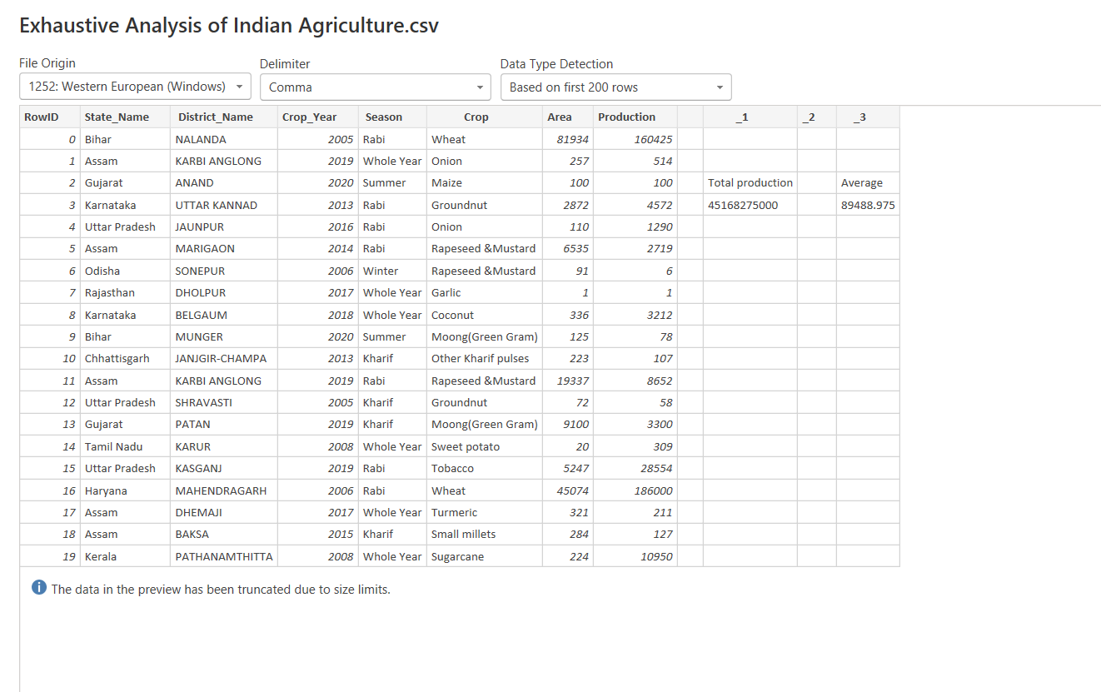

Step 2) We learn about ,what is load and transform data buttons.

In this task we click on load button and done further process.

Then we learn about different views like –

1. Report view
2. Table view
3. Model view

Below picture shows the table view of the dataset of Exhaustive Indian Agriculture Sector.

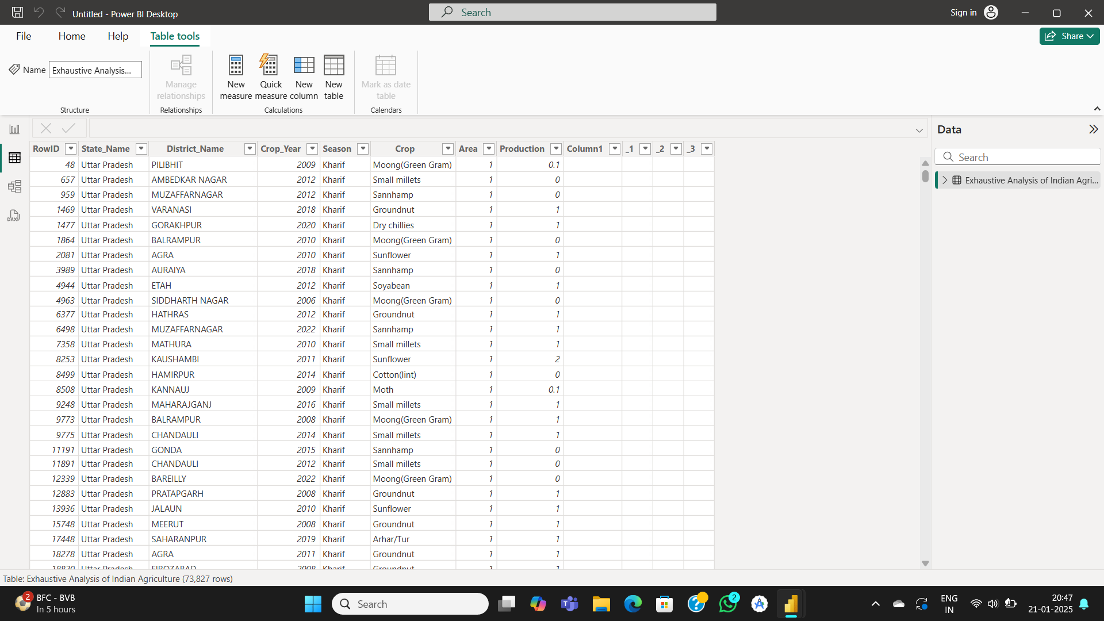

Step 3) After this we remove default row that is not needed.

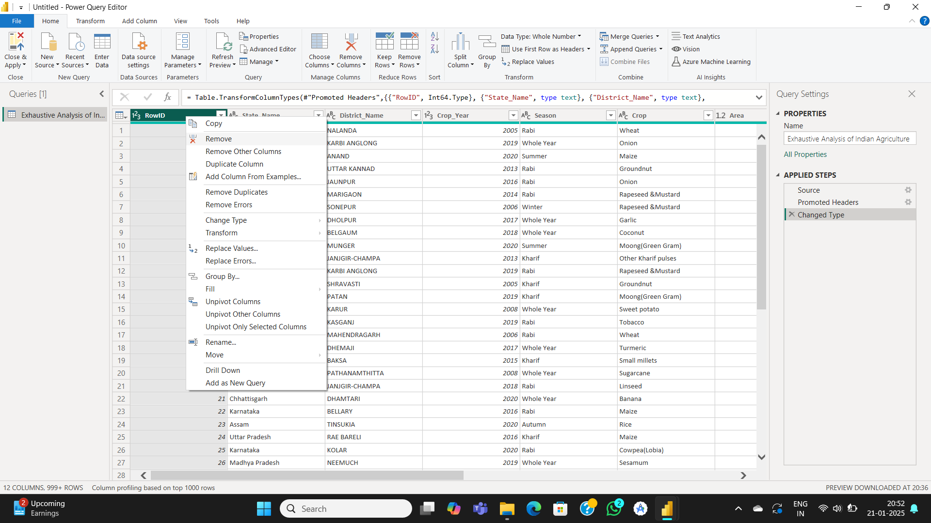

Step 4) Then we move to view tab and study that what exactly the column quality option is use for…

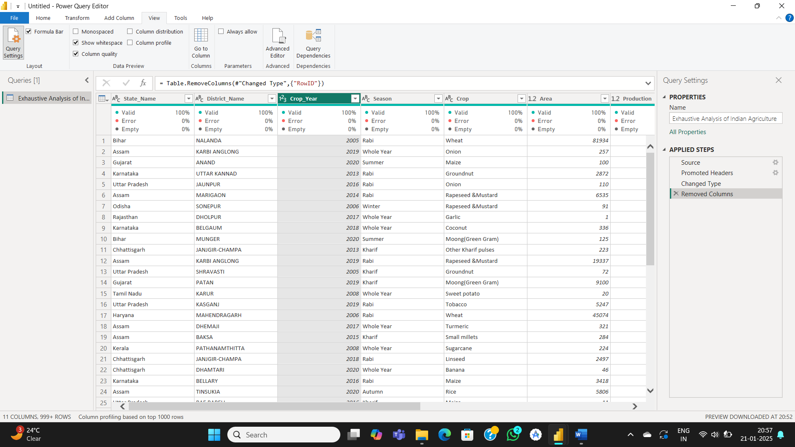

Step 5) Then if our data contains any NULL values or Rows then tab on Remove rows option in home tab and a list is appeared.

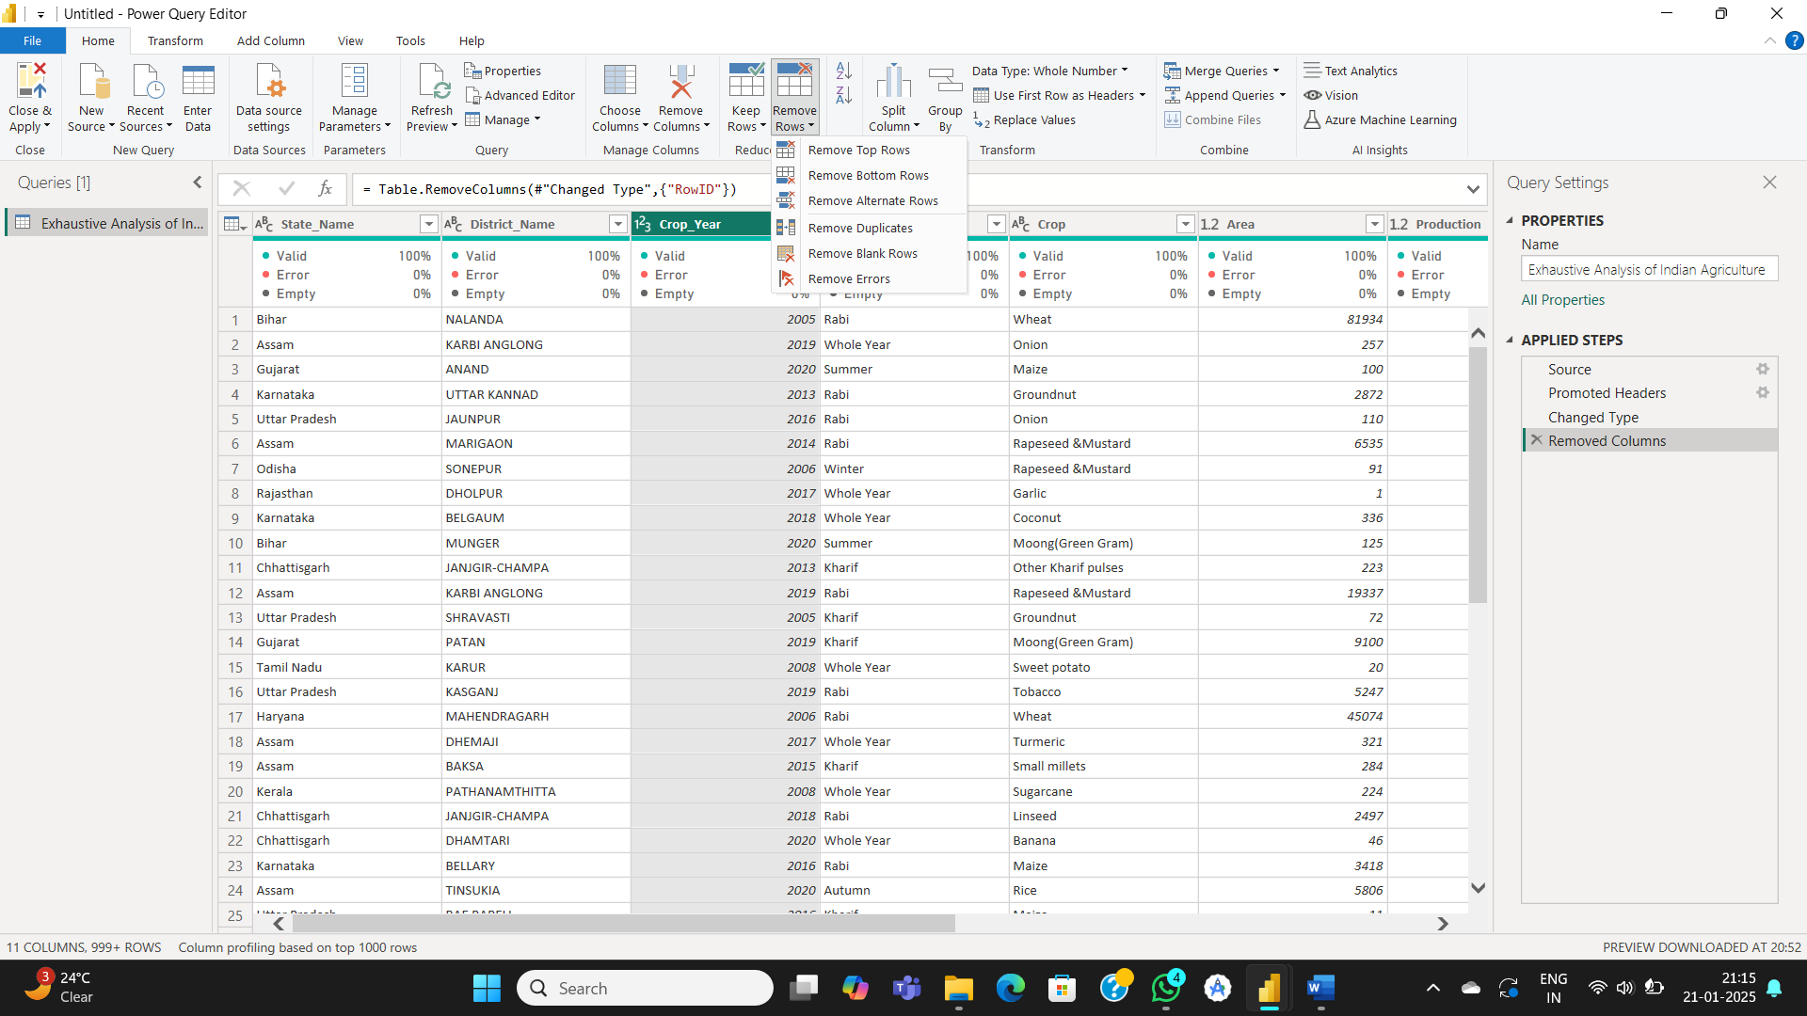

Atlast we close and apply … and that’s it…